
VISVESVARAYA TECHNOLOGICAL UNIVERSITY

BELAGAVI – 590018, Karnataka INTERNSHIP REPORT

ON

“Development of a Smart Spoon for Enhancing Taste Perception Using Electric Stimulation”
Submitted in partial fulfilment for the award of degree(21)

BACHELOR OF ENGINEERING IN

INFORMATION SCIENCE & ENGG
Submitted by:
RAKSHITH V

1EW21IS084


Conducted at
COMPSOFT TECHNOLOGIES


EAST WEST INSTITUTE OF TECHNOLOGY
DEPT. OF INFORMATION SCIENCE & ENGINNERING
Approved by AICTE and accredited by NBA and NAAC
No.63, Near BEL Layout, Off Magadi Road, Vishwaneedham Post, Anjananagar, Bengaluru-560091

EAST WEST INSTITUTE OF TECHNOLOGY
DEPT.OF INFORMATION SCIENCE AND ENGINEERING
Approved by AICTE and accredited by NBA and NAAC
No.63, Near BEL Layout, Off Magadi Road, Vishwaneedham Post, Anjananagar, Bengaluru-560091.



CERTIFICATE

This is to certify that the Internship titled “Development of a Smart Spoon for Enhancing Taste Perception Using Electric Stimulation” carried out by Mr. RAKSHITH V, a bonafide student of East West Institute of Technology, in partial fulfillment for the award of Bachelor of Engineering, Information Science and Engineering under Visvesvaraya Technological University, Belagavi, during the year 2024-2025. It is certified that all corrections/suggestions indicated have been incorporated in the report.
The project report has been approved as it satisfies the academic requirements in respect of Internship prescribed for the course Internship / Professional Practice (21CSI85)

Signature of Guide Signature of HOD Signature of Principal

External Viva:

Name of the Examiner Signature with Date

1)

2)

D E C L A R A T I O N

I, RAKSHITH V, final year student of Information Science and Engg, East West Institute of Technology - 560091, declare that the Internship has been successfully completed, in COMPSOFT TECHNOLOGIES. This report is submitted in partial fulfillment of the requirements for award of Bachelor Degree in Branch name, during the academic year 2024-2025.

Date : :
Place : BENGALURU
USN : 1EW21IS084
NAME :RAKSHITH V
OFFER LETTER



Internship Offer Letter

Date: 6th September, 2024

Name: Rakshith V
USN: 1EW21IS084
Intern ID: CMPSTSEP212

Dear Rakshith V,
We are delighted to offer you a Data Science Internship position at our company, with a spe- cific focus on medical-related projects. Your onboarding as an Intern is scheduled to begin on September 13th, 2024. We are impressed by your skills and eager to support your professional growth in this exciting and impactful field.
This internship will immerse you in the world of data-driven healthcare solutions. You’ll work closely with our experienced data science team, gaining valuable insights into the application of data science techniques for medical research and innovation. Expect to tackle real-world challenges, contributing directly to projects that have the potential to improve patient outcomes and advance medical knowledge.
Highlights:

Potential for Extension: Based on your performance and project needs, your internship may be extended beyond the initial timeframe.
Performance Recognition: Outstanding interns may be rewarded with stipends to acknowledge their significant contributions.
Future Opportunities: Exceptional performance and alignment with our company cul- ture could lead to consideration for full-time roles upon internship completion.
Professional Endorsement: A letter of recommendation will be provided upon success- ful completion of the internship, bolstering your future career prospects.
Next Steps:

We will share onboarding details with you soon, The same shall be communicated in the official whatsapp group .
Please be prepared to visit our office on a scheduled date to receive your ID card and access credentials, inorder to receive your ID cards you need to fill the google form sent to you via email or present in the bio/description of the offical whatsapp group with appropriate details such as Intern ID,usn etc
Throughout your internship, we expect a commitment to professionalism and adherence to company policies. We have no doubt that this experience will be both intellectually stimulating and professionally rewarding, equipping you with valuable skills and knowledge for a successful career in data science within the healthcare domain.
Congratulations on securing this internship. We eagerly anticipate your arrival and the fresh perspectives you will bring to our team!
Sincerely, Prasad K
Project Manager Compsoft Technologies No. 363, 19th Main Road, 1st Block Rajajinagar, Bangalore - 560010

A C K N O W L E D G E M E N T

This Internship is a result of accumulated guidance, direction and support of several important persons. We take this opportunity to express our gratitude to all who have helped us to complete the Internship.

We express our sincere thanks to our Principal, for providing us adequate facilities to undertake this Internship.

We would like to thank our Head of Dept – branch code, for providing us an opportunity to carry out Internship and for his valuable guidance and support.

We would like to thank our Teachers for Software Services for guiding us during the period of internship.

We express our deep and profound gratitude to our guide for their keen interest and encouragement at every step in completing the Internship.

We would like to thank all the faculty members of our department for the support extended during the course of Internship.

We would like to thank the non-teaching members of our dept, for helping us during the Internship.

Last but not the least, we would like to thank our parents and friends without whose constant help, the completion of Internship would have not been possible.

NAME : RAKSHITH V

USN : IEW21IS084

ABSTRACT

The integration of artificial intelligence in food recognition and consumer analysis is revolutionizing dietary management and user experience. This project leverages deep learning models, particularly Convolutional Neural Networks (CNNs), to identify food types and predict salt content, enabling automated dietary recommendations and adaptive electrical stimulation for taste enhancement.

AI-driven market research involves collecting and analyzing consumer preferences, real-world usage data, and the impact of taste modulation on sodium-restricted diets. Additionally, Natural Language Processing (NLP) models process user feedback for sentiment analysis, predicting behavioral patterns and refining personalization algorithms. By combining computer vision, data analytics, and AI-driven insights, this project aims to enhance dietary personalization, improve user satisfaction, and contribute to healthier eating habits.

This project explores the application of artificial intelligence in food recognition and consumer behavior analysis to enhance dietary personalization. Using computer vision techniques, particularly Convolutional Neural Networks (CNNs), the system identifies food types and predicts salt content, enabling automated dietary recommendations and adaptive electrical stimulation for taste enhancement.

AI-driven market research analyzes consumer preferences, real-world usage patterns, and the impact of taste modulation on sodium-restricted diets. Furthermore, Natural Language Processing (NLP) models process user feedback to conduct sentiment analysis and predict user behavior trends. By integrating AI-driven insights, this project aims to improve dietary management, enhance user experience, and support healthier eating habits.

This project leverages artificial intelligence to enhance food recognition and consumer insights for personalized dietary management. Utilizing Convolutional Neural Networks (CNNs), the system identifies food types and estimates salt content, enabling automated dietary recommendations and adaptive taste enhancement through electrical stimulation. AI-driven market research analyzes consumer preferences, real-world usage data, and the impact of taste modulation on sodium-restricted diets.

Table of Contents

Sl no | Description | Page no
1 | Company Profile | 9-10
2 | About the Company | 11-12
3 | Introduction | 13-14
4 | System Analysis | 15-17
5 | Requirement Analysis | 18-19
6 | Design Analysis | 20-22
7 | Implementation | 23-24
8 | Snapshots | 25-27
9 | Conclusion | 28-29
10 | References | 30

CHAPTER 1 COMPANY PROFILE

COMPANY PROFILE

A Brief History of Compsoft Technologies
Compsoft Technologies, was incorporated with a goal ”To provide high quality and optimal Technological Solutions to business requirements of our clients”. Every business is a different and has a unique business model and so are the technological requirements. They understand this and hence the solutions provided to these requirements are different as well. They focus on clients requirements and provide them with tailor made technological solutions. They also understand that Reach of their Product to its targeted market or the automation of the existing process into e-client and simple process are the key features that our clients desire from Technological Solution they are looking for and these are the features that we focus on while designing the solutions for their clients.
Compsoft Technologies, strive to be the front runner in creativity and innovation in software development through their well-researched expertise and establish it as an out of the box software development company in Bangalore, India. As a software development company, they translate this software development expertise into value for their customers through their professional solutions.
They understand that the best desired output can be achieved only by understanding the clients demand better. Compsoft Technologies work with their clients and help them to defiine their exact solution requirement. Sometimes even they wonder that they have completely redefined their solution or new application requirement during the brainstorming session, and here they position themselves as an IT solutions consulting group comprising of high caliber consultants.

They believe that Technology when used properly can help any business to scale and achieve new heights of success. It helps Improve its efficiency, profitability, reliability; to put it in one sentence ” Technology helps you to Delight your Customers” and that is what we want to achieve.

CHAPTER 2 ABOUT THE COMPANY

- ABOUT THE COMPANY

In an era defined by the relentless race for digital transformation, Compsoft Technologies stands at the forefront of empowering businesses to thrive in a globally connected, on-demand world. As industries—from healthcare, finance, and retail to energy, gaming, and transportation—scramble to build event-driven, real-time applications that capture market opportunities, Compsoft bridges the gap between cutting-edge innovation and practical implementation. Specializing in research-based, actionable data and machine learning solutions, the company pioneers unexplored domains, delivering data-supported insights that guide startups and investment firms toward strategic decision-making.

Compsoft’s expertise extends beyond theoretical exploration. With a proven track record in building scalable, real-time systems and world-class consulting processes, the company equips clients with tools to operationalize innovation efficiently. By integrating advanced machine learning models with event-driven architectures, Compsoft enables businesses to unlock transformative capabilities—whether enhancing financial reporting, optimizing operational performance, or deploying AI-driven medical research platforms. Their end-to-end approach combines rigorous Theoretical Analysis, bespoke Model Development, and granular Market Research to ensure solutions are not only technologically robust but also aligned with global trends and user demands.

Driven by a mission to simplify the development and deployment of real-time applications, Compsoft delivers unparalleled cost-benefits, consistent project execution, and measurable business outcomes. Their work spans strategic goal-setting, performance management, and financial optimization, all while adhering to strict confidentiality protocols through NDAs and proprietary safeguards. For clients and interns alike, Compsoft offers a dynamic platform to shape the future of industries, merging exploratory research with scalable, real-world impact in the fast-evolving landscape of data science and digital innovation.

CHAPTER 3 INTRODUCTION

- INTRODUCTION

Introduction to Data Science

Data Science is an interdisciplinary field that combines statistics, mathematics, programming, and domain expertise to extract meaningful insights from structured and unstructured data. It leverages techniques from machine learning, artificial intelligence, and big data analytics to analyze and interpret complex data sets, enabling data-driven decision-making across various industries.
In today's digital age, vast amounts of data are generated daily from social media, e-commerce transactions, healthcare records, financial transactions, and IoT devices. Data Science helps in processing and analyzing this data to uncover hidden patterns, trends, and correlations, ultimately leading to better business strategies, automation, and innovation.

Problem Statement

Traditional dietary management and taste enhancement methods often lack personalization, making it challenging for individuals, especially those on sodium-restricted diets, to maintain both health and satisfaction. Current food recognition systems do not effectively integrate real-time AI-driven insights to assess nutritional content and user preferences. Additionally, existing market research methods fail to leverage deep learning and sentiment analysis to understand consumer behavior and improve dietary recommendations.

This project aims to develop an AI-powered food recognition and analysis system that utilizes computer vision (CNNs) to identify food types and predict salt content. It will also incorporate AI-driven market research and sentiment analysis using Natural Language Processing (NLP) to analyze user feedback, predict behavior patterns, and enhance personalization. By integrating these technologies, the project seeks to improve dietary decision-making, enhance taste experiences, and promote healthier eating habits.

By combining food recognition, predictive modeling, and consumer behavior analysis, this project seeks to enhance dietary personalization, improve user experience, and contribute to healthier eating habits. The ultimate goal is to create an intelligent system that not only identifies food but also optimizes taste experiences while maintaining dietary restrictions, thus offering a comprehensive solution for improved nutrition and well-being.

In today's fast-paced world, dietary habits play a crucial role in maintaining overall health. However, individuals, especially those on sodium-restricted diets, face challenges in accurately identifying the nutritional content of their food and making informed dietary choices. Existing food recognition systems lack precision in estimating salt content and do not offer personalized recommendations based on real-time analysis. Additionally, traditional market research methods are insufficient in capturing consumer preferences and behavioral patterns, limiting advancements in dietary enhancement technologies.

CHAPTER 4 SYSTEM ANALYSIS

4. SYSTEM ANALYSIS

Existing System

Currently, food recognition and dietary management rely on manual input, generic recommendations, and limited AI-based solutions. Traditional food identification methods lack accuracy in determining nutritional content, particularly salt levels, making it difficult for individuals with dietary restrictions to make informed choices. Existing AI-powered food recognition systems primarily focus on image classification without integrating real-time nutritional analysis or adaptive taste enhancement.

Additionally, consumer behavior analysis in the food industry is based on conventional surveys and feedback mechanisms, which may not effectively capture sentiment or predict user preferences. Market research lacks AI-driven insights, making it challenging to personalize recommendations and improve user satisfaction.

Furthermore, current systems do not integrate sentiment analysis to understand user feedback effectively. As a result, there is no mechanism to track user satisfaction, predict behavioral patterns, or improve personalization algorithms. Lastly, individuals on sodium-restricted diets often struggle with reduced taste perception, and existing solutions do not offer adaptive taste enhancement techniques, such as electrical stimulation, to improve their dining experience.

The current dietary management and food recognition systems have several limitations. Many applications require users to manually log their meals, which is a tedious and error-prone process. This lack of automation often leads to inaccurate tracking of nutritional intake, making it difficult for individuals to maintain a balanced diet. Additionally, while some AI-based food recognition systems exist, they primarily focus on basic food classification without offering detailed nutritional analysis, particularly for specific elements like salt content.

2.Proposed System

The proposed system introduces an AI-powered food recognition and analysis platform that integrates computer vision, predictive modeling, and consumer behavior analytics. Using Convolutional Neural Networks (CNNs), the system will accurately identify food types and estimate salt content, allowing for real-time dietary recommendations. Adaptive electrical stimulation techniques will be implemented to enhance taste experiences for individuals with sodium-restricted diets.

Additionally, AI-driven market research will analyze consumer preferences using real-world data and sentiment analysis through Natural Language Processing (NLP). This will help predict user behavior, identify patterns in dietary adaptation, and enhance personalization algorithms for better user experience.

Additionally, AI-driven market research will be integrated to analyze consumer preferences and real-world usage data. Instead of relying on static surveys, the system will leverage machine learning to track user behavior, identify trends, and refine recommendations accordingly. Natural Language Processing (NLP) techniques will also be used to process user feedback, perform sentiment analysis, and detect patterns in user satisfaction. This will enable continuous improvement in dietary recommendations, making them more personalized and effective over time.

By combining advanced AI techniques, the proposed system will offer a comprehensive solution that not only identifies food items but also enhances taste perception, analyzes consumer behavior, and personalizes dietary recommendations, ultimately promoting health.

3.Objective of the System

To develop an AI-based food recognition system using computer vision techniques (CNNs) for accurate food identification and salt content prediction.

To provide automated dietary recommendations based on food recognition and nutritional analysis.

To enhance taste experiences using adaptive electrical stimulation for individuals with dietary restrictions.

To conduct AI-driven market research by analyzing real-world consumer preferences and behavioral patterns.

To implement sentiment analysis using NLP for processing user feedback and improving personalization algorithms.

To improve dietary personalization, promote healthier eating habits, and enhance user satisfaction through AI-powered insights.

The primary objective of this system is to develop an AI-powered food recognition model that accurately identifies food types and estimates salt content using deep learning techniques.

This will help users make informed dietary choices and maintain a healthier lifestyle.

CHAPTER 5 REQUIREMENT ANALYSIS

5. REQUIREMENT ANALYSIS

Hardware Requirement Specification
The proposed system requires a combination of computational and sensory hardware components to effectively implement food recognition, taste enhancement, and AI-driven analysis. The essential hardware requirements include:
- Processor
- GPU
- RAM
- Storage
- Camera module

Software Requirement Specification
The software environment must support AI-driven food recognition, machine learning model development, and sentiment analysis. The key software requirements include:
- Operating System: Windows 10/11, macOS, or Linux (Ubuntu recommended) for software development and deployment.
- Programming Languages:
- Python (for AI and machine learning model development)
- JavaScript (Node.js, React) (for web-based user interface)
- Machine Learning & Deep Learning Libraries:
- TensorFlow / PyTorch (for CNN-based food recognition)
- OpenCV (for image processing and real-time analysis)
- Scikit-learn (for data analysis and classification tasks)
- Pandas & NumPy (for data handling and preprocessing)
- Natural Language Processing (NLP) Libraries:
- NLTK / SpaCy (for sentiment analysis and user feedback processing)
- Database Management System:
- PostgreSQL / MySQL / MongoDB (for storing user data, feedback, and model outputs)
- Web Development Frameworks (if applicable):
- Django / Flask (for API development)
- React / Angular (for front-end development)
- Cloud Services (optional):
- AWS / Google Cloud / Azure (for deploying AI models and hosting services)
- Version Control:
- Git / GitHub (for collaborative development and source code management)

CHAPTER 6 DESIGN ANALYSIS

- DESIGN & ANALYSIS

The system is designed as an AI-driven food recognition and dietary recommendation platform, integrating computer vision, predictive modeling, and user sentiment analysis. The architecture consists of multiple layers, including a front-end interface for user interaction, a back-end AI processing unit, and a database for storing user data and model outputs.

At the core of the system, Convolutional Neural Networks (CNNs) are employed for food recognition, allowing the model to classify food items based on captured images. The AI model estimates the salt content in food and suggests modifications based on dietary needs. An additional component for adaptive taste enhancement utilizes electrical stimulation to enhance flavor perception for individuals on sodium-restricted diets. The system also incorporates Natural Language Processing (NLP) to analyze user feedback, enabling continuous improvement in recommendations.

A cloud-based infrastructure is considered for scalability, allowing AI models to be trained and deployed efficiently. The user interface is designed with a responsive web or mobile application, enabling users to upload food images, receive recommendations, and provide feedback. A database management system (PostgreSQL/MySQL/MongoDB) is used to store food-related data, user preferences, and AI-generated insights. The entire design ensures seamless integration between AI-based food recognition, nutritional analysis, and user experience enhancement.

The system follows a modular design approach, where each component is developed independently and seamlessly integrated. The architecture consists of three primary modules: Food Recognition, Nutritional Analysis & Taste Enhancement, and User Behavior Analysis. The food recognition module uses CNNs for image classification, allowing real-time identification of food items and estimation of salt content. The nutritional analysis module processes this data to provide dietary recommendations, while the user behavior analysis module applies NLP techniques to analyze sentiment and predict user satisfaction. This modular approach ensures flexibility, scalability, and ease of maintenance.

The system follows a structured data flow for processing input images and user interactions. When a user uploads a food image, it is preprocessed using OpenCV to enhance image quality. The preprocessed image is then fed into the CNN model, which classifies the food type and estimates its nutritional content, including salt levels. Simultaneously, the NLP-based sentiment analysis module processes user feedback and adapts recommendations accordingly. The processed data is stored in a database, ensuring that user preferences and historical data are available for future recommendations.

To handle real-time image recognition and AI-driven analysis efficiently, the system leverages cloud-based processing with AWS/GCP/Azure. Cloud integration allows AI models to process large datasets quickly and deploy updates seamlessly. Additionally, edge computing techniques can be implemented to perform initial food classification on a user’s device before sending data to the cloud, reducing latency. The system ensures a smooth user experience by balancing on-device and cloud-based processing to deliver fast and accurate results.

The accuracy and efficiency of the CNN-based food recognition model are tested using benchmark datasets such as Food-101 and UECFOOD-256. The model’s performance is evaluated using metrics like accuracy, precision, recall, and F1-score. Additionally, hyperparameter tuning is conducted to optimize layers, learning rates, and activation functions, ensuring high classification accuracy. Real-world testing is performed to validate the model’s effectiveness in identifying diverse food items with varying lighting conditions and angles.

The NLP module analyzes user feedback collected from reviews, comments, and ratings. Lexicon-based and machine learning-based sentiment analysis methods are employed to detect positive, neutral, and negative sentiments. The impact of feedback-driven personalization is measured by comparing user engagement before and after implementing adaptive recommendations. The results determine how effectively the system can adjust its dietary suggestions based on sentiment trends.

The system’s computational efficiency is analyzed by monitoring CPU, GPU, and memory usage during real-time food recognition and sentiment analysis. Techniques such as model pruning, quantization, and batch processing are applied to reduce computational overhead while maintaining accuracy. The response time of the AI models is also evaluated, ensuring that food recognition and recommendation processing occur within an acceptable timeframe (<2 seconds). Efficient resource allocation strategies are employed to balance speed and accuracy, making the system suitable for large-scale deployment.

The adaptive taste enhancement mechanism is analyzed based on user feedback and real-world testing, ensuring that electrical stimulation provides noticeable improvements in flavor perception. The impact of AI-driven dietary recommendations is measured by tracking user satisfaction and adherence to suggested modifications.

For sentiment analysis, NLP models process real-time user reviews to detect patterns in user preferences. The efficiency of the system is analyzed based on response time, ensuring real-time predictions and feedback processing. Computational resource usage (CPU, GPU, and memory) is optimized to maintain system performance, making it feasible for large-scale deployment.

The system analysis focuses on evaluating performance, accuracy, and efficiency across various components. Food recognition models are trained using diverse datasets to ensure high classification accuracy, especially for distinguishing visually similar food items. Performance metrics such as precision, recall, and F1-score are used to validate the accuracy of food identification and salt content estimation.

CHAPTER 7 IMPLEMENTATION

- IMPLEMENTATION

Implementation is the stage where the theoretical design is turned into a working system. The most crucial stage in achieving a new successful system and in giving confidence on the new system for the users that it will work efficiently and effectively.
The system can be implemented only after thorough testing is done and if it is found to work according to the specification. It involves careful planning, investigation of the current system and it constraints on implementation, design of methods to achieve the change over and an evaluation of change over methods a part from planning.
Two major tasks of preparing the implementation are education and training of the users and testing of the system. The more complex the system being implemented, the more involved will be the system analysis and design effort required just for implementation.

The implementation phase comprises of several activities. The required hardware and software acquisition is carried out. The system may require some software to be developed. For this, programs are written and tested. The user then changes over to his new fully tested system and the old system is discontinued.

TESTING
The testing phase is an important part of software development. It is the Information zed system will help in automate process of finding errors and missing operations and also a complete verification to determine whether the objectives are met and the user requirements are satisfied. Software testing is carried out in three steps:
- The first includes unit testing, where in each module is tested to provide its correctness, validity and also determine any missing operations and to verify whether the objectives have been met. Errors are noted down and corrected immediately.
- Unit testing is the important and major part of the project. So errors are rectified easily in particular module and program clarity is increased. In this project entire system is divided into several modules and is developed individually. So unit testing is conducted to individual modules.
- The second step includes Integration testing. It need not be the case, the software whose modules when run individually and showing perfect results, will also show perfect results when run as a whole.

CHAPTER 8 SNAPSHOTS

  - SNAPSHOTS

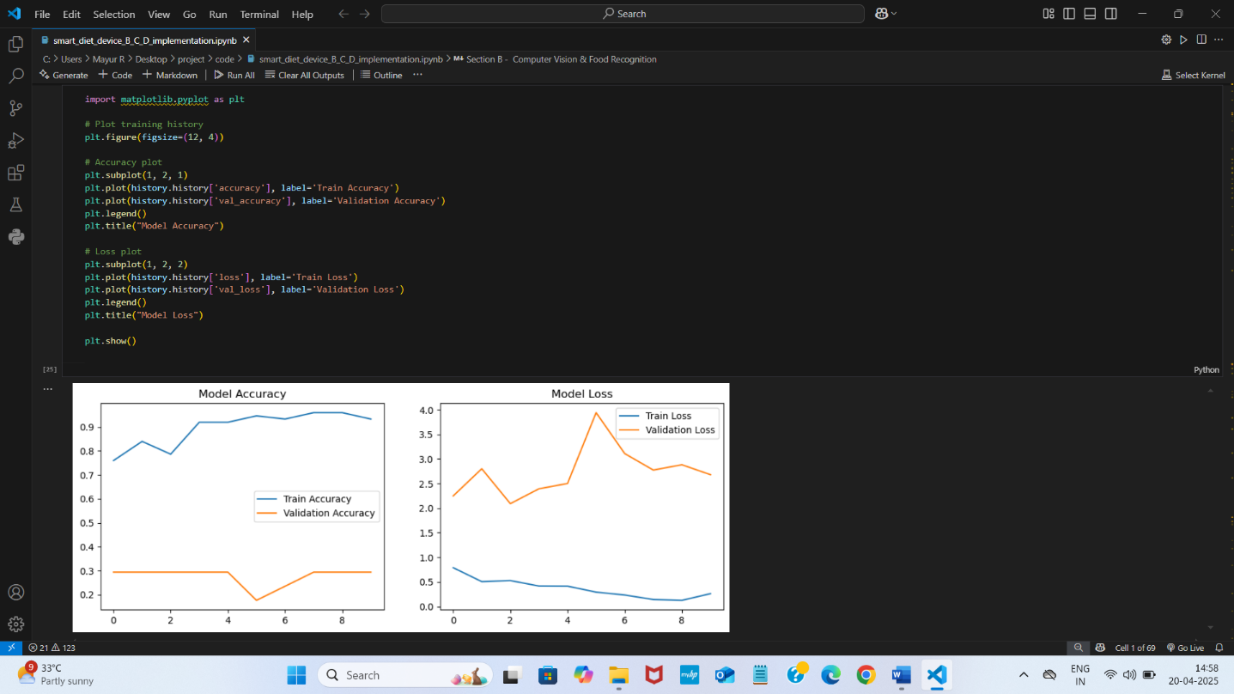

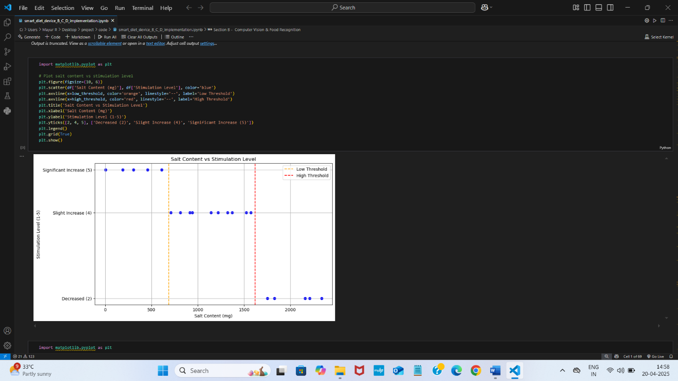

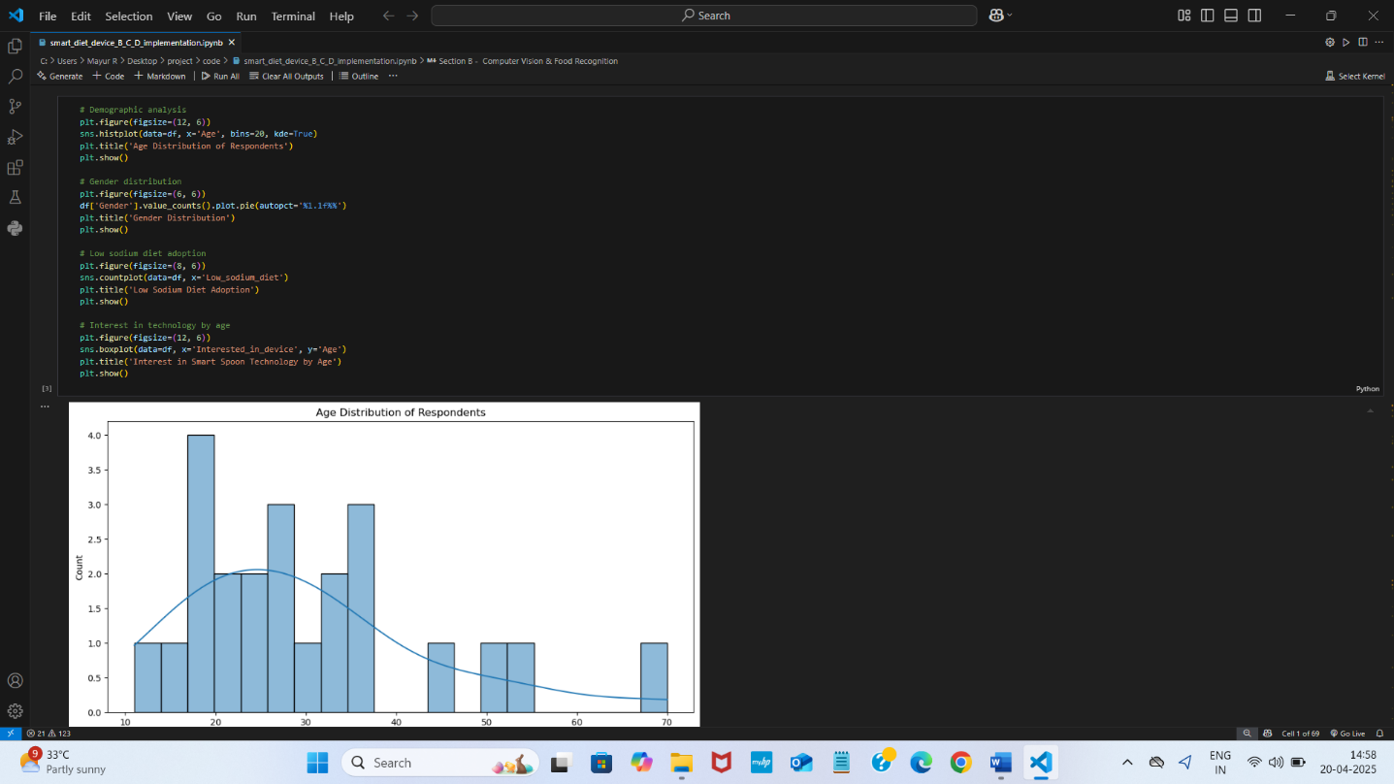

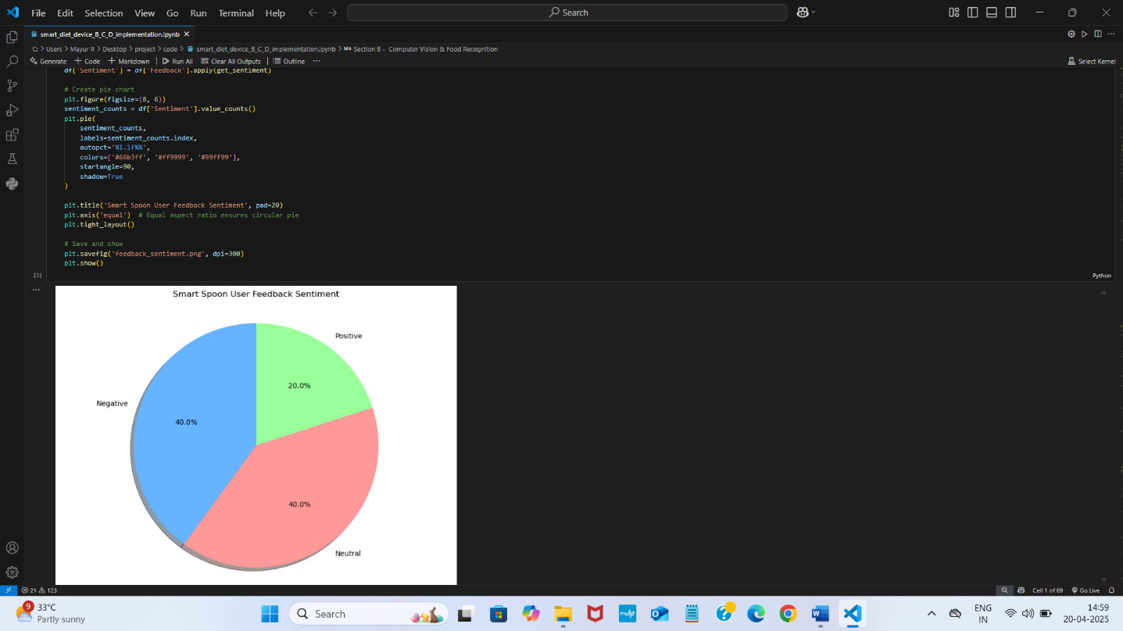

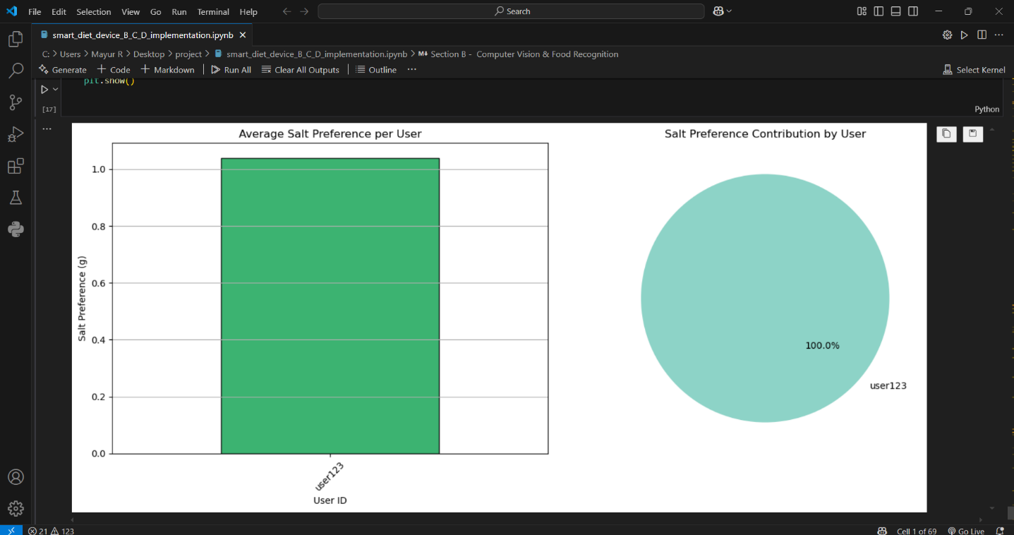

CHAPTER 9 CONCLUSION

  - CONCLUSION

The package was designed in such a way that future modifications can be done easily. The following conclusions can be deduced from the development of the project:

- Automation of the entire system improves the efficiency

- It provides a friendly graphical user interface which proves to be better when compared to the existing system.

- It gives appropriate access to the authorized users depending on their permissions.

- It effectively overcomes the delay in communications.

- Updating of information becomes so easier

- System security, data security and reliability are the striking features.

- The System has adequate scope for modification in future if it is necessary.

REFERENCE

- Google Scholar - https://scholar.google.com/
- ChatGPT & OpenAI Documentation - https://openai.com/research/
- TensorFlow Documentation - https://www.tensorflow.org/tutorials
- PyTorch Documentation - https://pytorch.org/tutorials/
- Scikit-learn Documentation - https://scikit-learn.org/stable/user_guide.html
- Kaggle Datasets - https://www.kaggle.com/datasets
- Natural Language Toolkit (NLTK) & SpaCy Documentation - • https://www.nltk.org/
• https://spacy.io/
- Google Cloud Vision API - https://cloud.google.com/vision
- IEEE Xplore Digital Library - https://ieeexplore.ieee.org/
- MDPI – Nutrients Journal - https://www.mdpi.com/journal/nutrients

